INTRODUCTION:
Portal frame construction is a method of building and designing simple structures, primarily using steel or steel-reinforced precast concrete although they can also be constructed using laminated timber such as glulam. The connections between the columns and the rafters are designed to be moment-resistant, i.e. they can carry bending forces.
Because of these very strong and rigid joints some of the bending moment in the rafters is transferred to the columns. This means that the size of the rafters can be reduced or the span can be increased for the same size rafters. This makes portal frames a very efficient construction technique to use for wide span buildings.
Portal frame construction is therefore typically seen in warehouses, barns and other places where large, open spaces are required at low cost and a pitched roof is acceptable.
Generally portal frames are used for single story buildings but they can be used for low rise buildings with several floors where they can be economic if the floors do not span right across the building (in these circumstances a skeleton frame, with internal columns, would be a more economic choice). A typical configuration might be where there is office space built against one wall of a warehouse.
Portal frames can be clad with all sorts of material but the most popular solution, for reasons of economy and speed, is some form of lightweight insulated metal cladding with cavity masonry work to the bottom 2m of the wall to provide security and impact resistance. The lightweight cladding would be carried on sheeting rails spanning between the columns of the portal frames.
OBJECTIVE:
To know the shear force diagram and bending moment diagram for a given portal frame.
THEORY:
Portal frames are frequently used over the entrance of a bridge and as a main stiffness element in building design in order to transfer horizontal forces applied at the top of the frame to the foundation. On bridges, these frames resist the forces caused by wind, earthquake, and unbalanced traffic loading on the bridge deck. Portals can be pin supported, fixed supported, or supported by partial fixity. The approximate analysis of each case will now be discussed for a simple three-member portal.
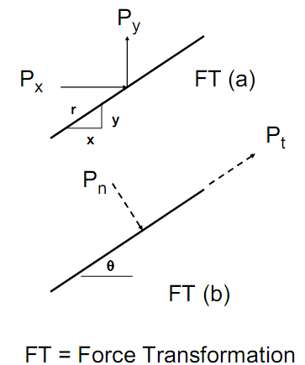
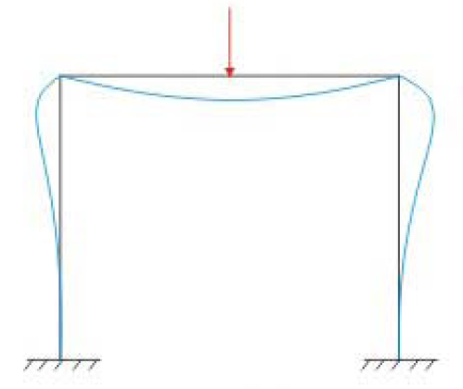
Suppose you are given the forces in FT (a) and you wish to transform these forces into Pn (normal) and Pt (tangential) as shown in FT (b). This force transformation may be necessary so that you can calculate the member axial and shear forces. These force transformations are summarized as
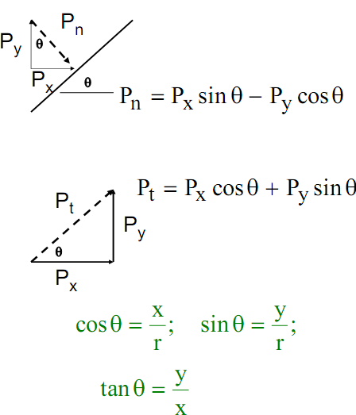

Representation of Frame when load is acting:

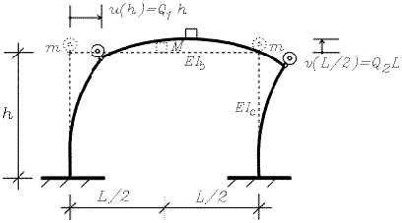

Types of frames under loadings:
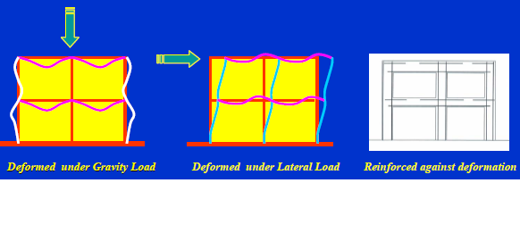

Global Modeling of structural geometry:
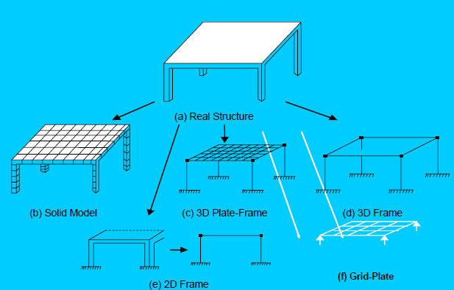

Advantages of frames:
- Optimum use of floor space
- Easy construction.
- Rapid construction
- Economical for high rise buildings.
- Erected by steel or reinforced concrete.

SNAP SHOTS:
- Load applied at center of frame
- Load applied at concentrated point.
QUIZ:
- What is a portal frame?
- Give the examples where portal frames are used.
- What is the degree of freedom for a portal frame with fixed support?
- What are the types of connections in building frames?
- Portal frames can be pinned, hinged or may also be as fixed. (T/F)
- The maximum bending moment is at the middle when u.d.l is applied for a fixed portal frame. (T/F)

PART – 2
ANIMATION STEPS
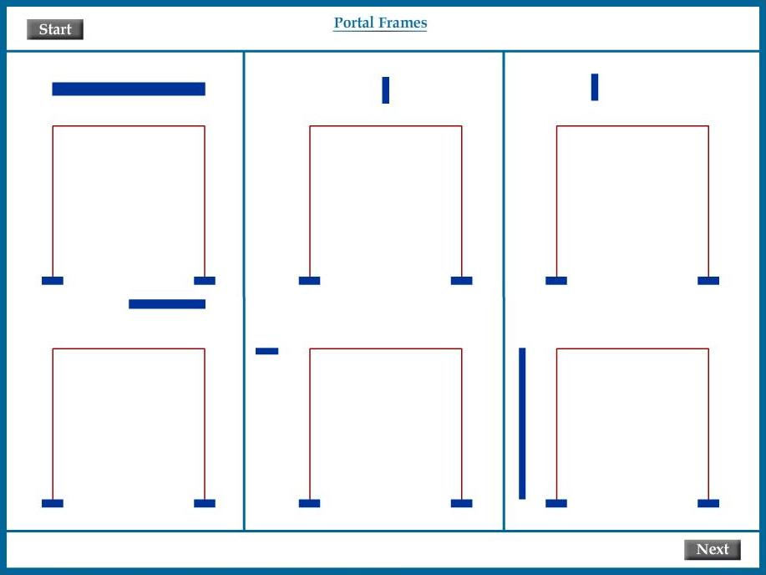

PART – 3
VIRTUAL LAB FRAME

